NAME________________________LAB MEETING DAY/TIME___________________

Lab 4, Sedimentary Stratigraphy - KEY
Lab 4 will cover Exercises 5 and 6 in your lab manual. Your TA will go over each exercise prior to you working through the questions; this will help orient you to the main topics covered in this lab – lithostratigraphy, biostratigraphy, and chronostratigraphy.

Exercise 5 – Part A
Complete questions 1 and 2 on the right side of the figure below. Complete question 3 on the left side of the figure.
For questions 1 and 2, students will provide names for formations. An example using figure 5.5 is provided below. For question 3, students should provide a brief description of each formation on figure 5.5 that includes the rock type and thickness to the left of the figure.

Exercise 5 – Part B
Using the directions on page 65 of the lab manual, complete the figure below.

On figure 5.6, students should draw formation contact lines parallel to contours at the elevations specified for the formation boundaries and color the areas in between with colors of their choosing. Or you may specify a color for each formation.

Then, answer the question given on page 65: What is the relationship between geological contact lines and topographic contour lines when the formations are oriented horizontally?
As they create this geological map they should notice that contours and contacts are parallel when strata are horizontal.

Exercise 5 – Part c
Complete questions 1, 2, 3, and 4 using this figure.
See figure 5.8B below with species ranges and zones delineated. Students should color the stratigraphic column at the right of the figure below to understand that zones are bodies of rock.
The intent of this activity is to help students recognize that zones are bodies of rock. Students should delineate, color, and label the three zones. Note that the intervals between 150 and 300 ft and between 350 and 400 ft are not zoned.
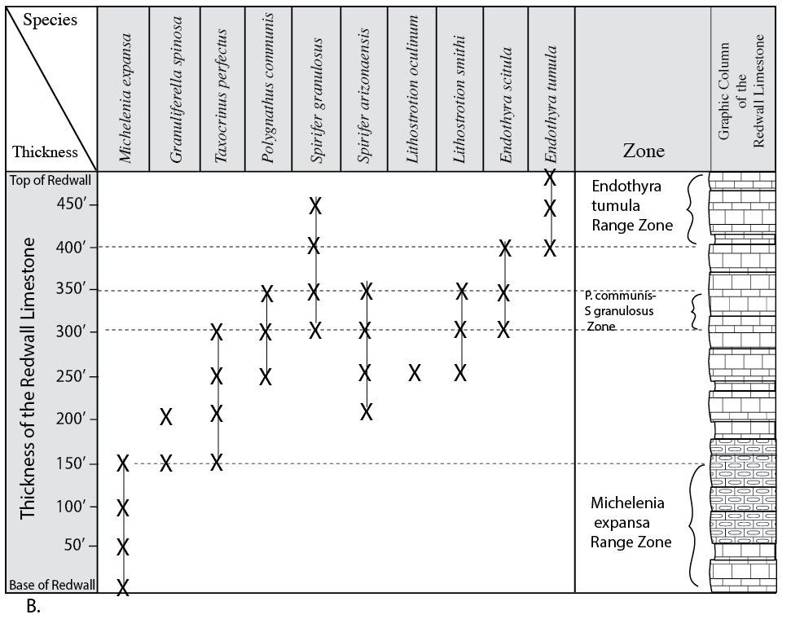

5.
Michelenia expansa zone contains one species, Polygnathus communis-Spirifer granulosa zone contains six species, and the Endothyra tumula Zone contains three species. AVERAGE???
6.
Endothyra tumula zone; the name-bearing species is restricted to its range zone.
7.
Polygnathus communis and Spirifer granulosa both occur outside of their name-bearing zone.

YOu May skip Exercise 5 – Part D

Exercise 5 – Part E
Complete the figure below using the directions on page 75
Students should draw lines parallel to the contours that correspond with the base of each Paleozoic System indicated and color the outcrop trend of each system.
Answer this question: How does this map compare to the geological map you drew in Part B. Are they similar or different? Do you expect this? Explain in terms of concepts of stratigraphy.
Students should recognize similarities in the two, and discuss the similarities in terms of stratigraphic relationships.

Exercise 5 – Part F
Follow the directions on page 76 to complete the table below. The first one has been done as an example.
See figure below. The first should actually read something like: Magnetic; first occurrence of Paragloborotalia kugleri; and/or Oxygen isotopic event Mi-1.
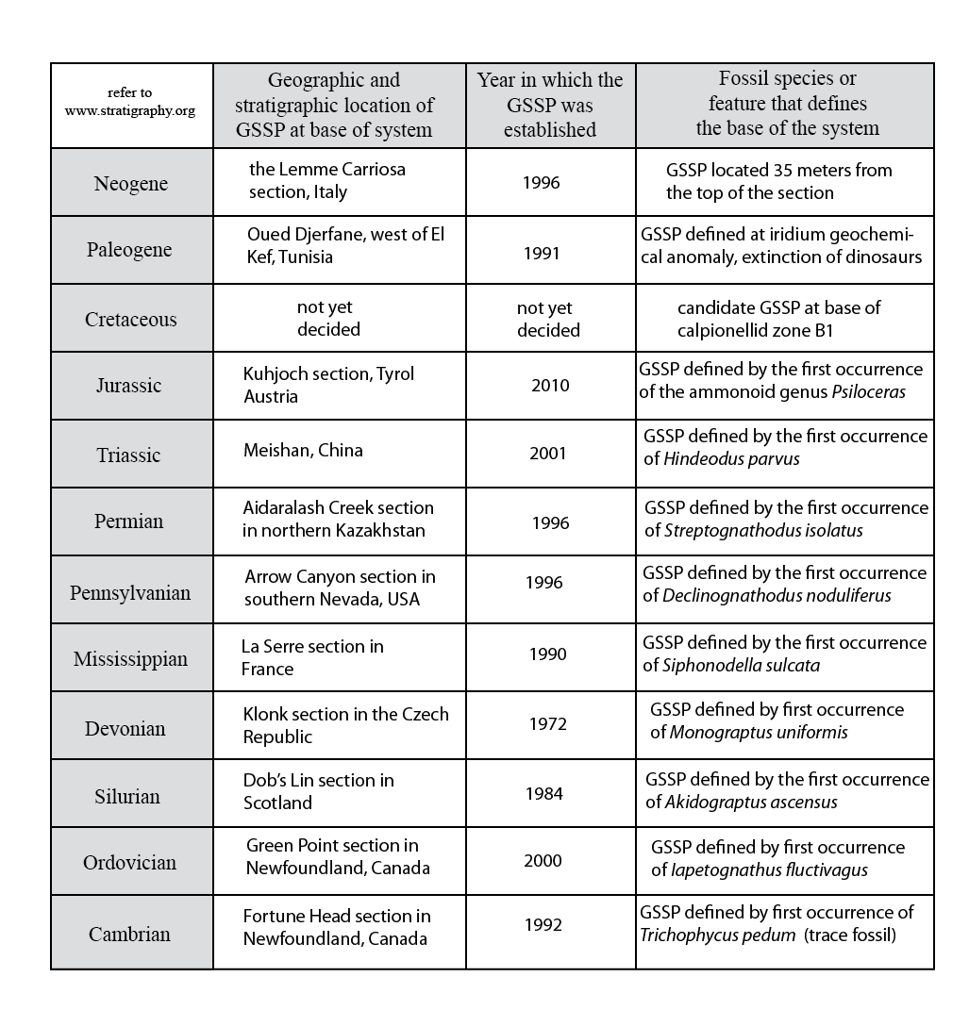

Exercise 6 – Part A
See figure below. Students should draw correlation lines between the labeled units on each column.
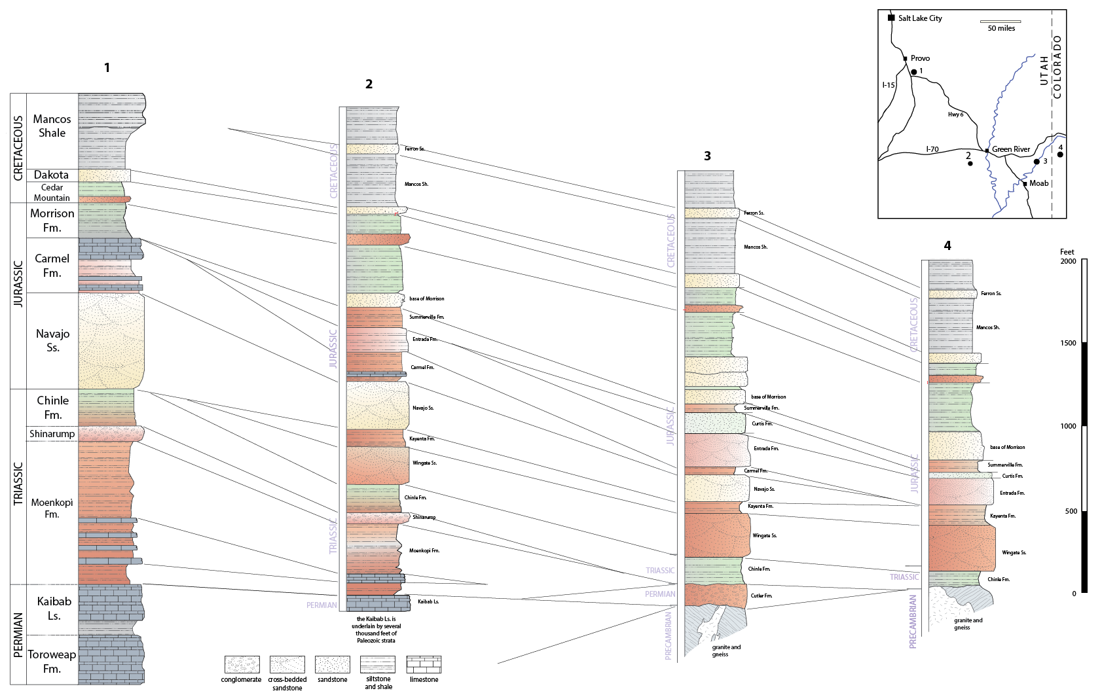
Then, answer the questions on page 87 below.

2.
Stratigraphic column | Name / Rock Type below Chinle Formation | Age
1 | Shinarump Formation | Triassic
2 | Shinarump Formation | Triassic
3 | Cutler Formation | Permian
4 | gneiss and granite | Precambrian
3.
In section 4, erosion has removed Paleozoic sedimentary rocks, exposing Precambrian crystalline rocks. Deposition of the Chinle Formation commenced atop this nonconformable surface. In section 3, erosional debris was deposited on top of the Precambrian surface, followed by deposition prior to deposition of the Chinle Formation. Erosion was due to uplift of the areas represented by sections 3 and 4 during late Pennsylvanian and Permian time. This episode of uplift in eastern Utah and western Colorado is known as the Ancestral Rockies uplift. In sections 1 and 2, uplift did not occur, hence late Paleozoic strata were preserved and early Triassic sediments (Moenkopi Formation) were deposited.
4.
The area represented by sections 3 and 4 were affected by the Ancestral Rockies uplift. See answer to question 3 above. Students do not have to be this specific, as we haven’t learned about this. But they should recognize intervals of erosion, uplift, and deposition.
5. a.
The Navajo Sandstone is an eolian deposit. The sand sea covered most of Utah, but did not extend eastward as far as western Colorado (section 4).
5. b.
The Entrada Sandstone is present in sections 2, 3, and 4, but pinches out westward, so is absent in section 1 due to nondeposition. Further, in sections 3 and 4, the Entrada is a cliff-forming (and arch-forming) eolian sandstone. It is well exposed at Arches National Park. In section 2, the Entrada is comprised of slope- and ledge-forming siltstone and shale, reflecting deposition in a marginal marine tidal flat.
5. c.
The Carmel Formation thins from west to east, being absent in section 4. In western sections 1 and 2, the Carmel contains marine limestone beds, which are absent in section 3.

Lab 4 Reflection
In your own words, describe the goals of lithostratigraphy, biostratigraphy, and chronostratigraphy.
What was an “ah-ha” moment you had during this lab? This is a time when something suddenly made more sense with additional knowledge.

